Searching for the Best Place to Establish an Vegetarian Restaurant in Toronto City

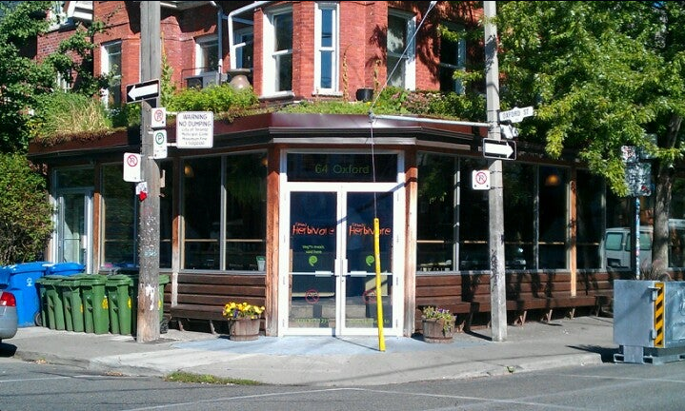

Introduction

As part of the capstone project I was assigned the task of formulating a hypothetical problem and coming up with a data science-oriented solution to unearth meaningful insights and conclusive results. The goal of this work it's to figure out the best locations for opening up a vegetarian restaurante in Toronto City. The prime aspect of such a business is to locate a place which has the least competition.

Target Audience

An Asian vegetarian food CEOs. Our Data Science work will be designed to help make the management decision of the company, comprehensively addressing the problem and then presenting the results obtained.

About the data

The data set required for the next project was acquired from three different data sources. The three data sources are listed below: • A Wikipedia page to search for districts and neighborhoods in the city of Toronto. • A .csv file to obtain latitudes and longitudes corresponding to each postal code. • Make RESTful API calls to the Foursquare API to retrieve data about places in different neighborhoods around the world. • Finally, I will use the Folium library to show the results geographically.

Metodología

The first step I will take is to extract data from the Wikipedia page that consisted of all the districts and neighborhoods along with their zip codes. Convert it to a data frame as they are the best data structure to work with when it comes to analysis using visualization techniques. The data frame still consisted of many values ​​that can be treated as missing values, since the ZIP codes were not assigned to any municipality or neighborhood. Missing values ​​can cause a discrepancy in the results as we approach the later stages of the project. So I'm going to remove all rows that had missing values ​​present in them.
The second step will include importing data from a .csv file. The .csv file consisted of the latitude and longitude coordinates for each zip code. This .csv file will be imported into a data frame to facilitate analysis at the later stage. Following which, I merged the data frame consisting of ward and neighborhood information and the data frame consisting of coordinate values. The merge was implemented in the zip code column which was later removed from the final table as it was not used for any further analysis.
The Wikipedia page contains a table of followed zip codes in Toronto, along with the boroughs and neighborhoods of the city of Toronto. The .csv file provides us with the latitude and longitude coordinates of each followed zip code in the Toronto region. This data is beneficial as these coordinates are used in conjunction with the Four Squares API to give a list of popular places in each neighborhood. The data is comprehensive and yields valuable information related to the city of Toronto that eventually helped us unearth conclusive results and observations. The data source, as perceived at the beginning of the project, is not clean and requires intensive pre-processing to turn it into a working set, capable of handling machine learning algorithms and visualization operations that were implemented in it. the shape of the table looks like this before entering the preprocessing phase of the project.
Finally, as soon as the data acquired from the data source has been processed using data pre-processing tools, we will start with data analysis with the goal of:
• Get a detail of the bairros of Toronto
• Know the number of vegetarian restaurants in each bairro
• Know the number of places ‘related’ to vegetarianism in each bairro
• Carry out a study of clusters using the 'K-Means' Machine Learning method.
• Merge the results obtained in a table to carry out a discussion of the results

Unlike most jobs that seek to find the best place to open a restaurant using the location of OTHER businesses in the same industry, in this job we will use some additional parameters.
Not always the Scientist has full knowledge of the matter that he analyzes. What's more, it generally DOES NOT HAVE IT.
For this reason, it is of real importance to give a specific context to the problem analyzed in a Data Science work. Basically knowing in detail the area in which we are working. That is why we will begin by understanding the difference between vegetarians, vegans, raw food persons, etc. It is important to know this because the ingredients of the recipes change radically.
Definition of Vegetarian: The vegetarian DOES NOT EAT meat but accepts foods derived from animal production: eggs, milk, honey, etc. The decision to be a vegetarian, according to the followers, is moral and ethical as well as healthy.
Vegetarianism is not a diet. It is a lifestyle"
In the end, data science tries to understand human behavior through methods and data taking advantage of computational power.
That is why we included 'activities related' to vegetarianism in our study.
They are:
- Yoga Studio
- Health Food Store
- Fruit & Vegetal Store
- Salad Place

Results

TOP TEN VENUES – ANALYSIS OF CLUSTERS
CLUSTER 1 | Yoga Studio | Health Food Store | Vegetarian restaurante | Fruit & Vegetable store | Salad Place
Downtown Toronto | 2 |  | 2 |  | 1
Etobicoke | 4
East York | 2
York | 2
East Toronto | 2 | 1 |  | 1
Scarborough | 5
Central Toronto | 3
West Toronto | 2
North York | 4
CLUSTER 2
North York | 1
CLUSTER 3
North York | 3
York | 1
CLUSTER 4
North York | 1
Etobicoke | 1
CLUSTER 5
Scarborough | 1

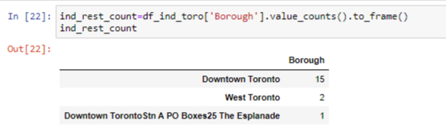

Based on the tables presented, we note at the beginning that vegetarian restaurants are not very popular in Toronto. The exception is the bairro in Dowtown Toronto, which has 2 quite popular vegetarian restaurants out of the 15 establishments it has in total.
East Toronto is a bairro that presents significant amounts with respect to the amount of ‘activities related’ to vegetarianism and does not count with any vegetarian restaurant registered in Foursquare, unlike West Toronto which has 2.

Conclusion

Solo 2 bairros de Toronto presentan condiciones para abrir un restaurante vegetariano. El que más se destaca es Downtown Toronto, donde ya existen vários restaurantes y algunos funcionando muy bien. La desventaja es que la competencia es muy fuerte.
El bairro de East Toronto parece una buena oportunidad. Tiene buenos índices de ‘actividades relacionadas’ al vegetarianismo y no tiene ningún restaurante vegetariano registrado em Foursquare.

